We brought you verified VoiceDrop coupons for business and sales teams, which let you save up to 40% on subscriptions, making this AI-powered ringless voicemail software highly affordable.

35% OFF VoiceDrop Promo Code on Annual Plans
Get 35% off on annual subscriptions using this VoiceDrop promo code and manage your ringless voicemail campaigns more efficiently with AI voice cloning, mass messaging, and CRM integrations built for scaling sales outreach.


Save Up to 40% With VoiceDrop Coupon
Save up to 40% on your VoiceDrop subscriptions with this exclusive coupon and get advanced features like DNC list management, SOC 2 Type II compliance, and detailed performance analytics that help teams stay organized and increase callbacks.


15% OFF VoiceDrop Discount Code for Your First Month
Claim 15% off your first month using the code VDRVMAI15 and streamline your lead handling through seamless Zapier and HubSpot integrations, allowing you to move beyond manual cold calling without jumping into expensive enterprise pricing.


Start Sending Ringless Voicemails for $95/Month
Get started for just $95/month to manage automated sales calls and notifications through custom voice clones designed for large contact lists, ensuring every message feels personal without disrupting the recipient.


Get a Free Trial & $20 in Credits on VoiceDrop [No Credit Card Required]
Get a free trial and $20 worth of credits to test VoiceDrop's ringless voicemail delivery hands-on. This includes approximately 200 messages over five days, ideal for first-time users who want to see results before fully committing.


VoiceDrop 15% Off Promo Code [New Users]
Save 15% as a new user with code VDRVMAI15 to reduce your initial costs, making it easier to scale your meetings and sales pipelines without paying full price in your first month.


How to Apply the VoiceDrop Coupon Code?
Follow these 4 simple steps to claim a VoiceDrop promo code.
Step 1: Visit the VoiceDrop official website with this discount link.
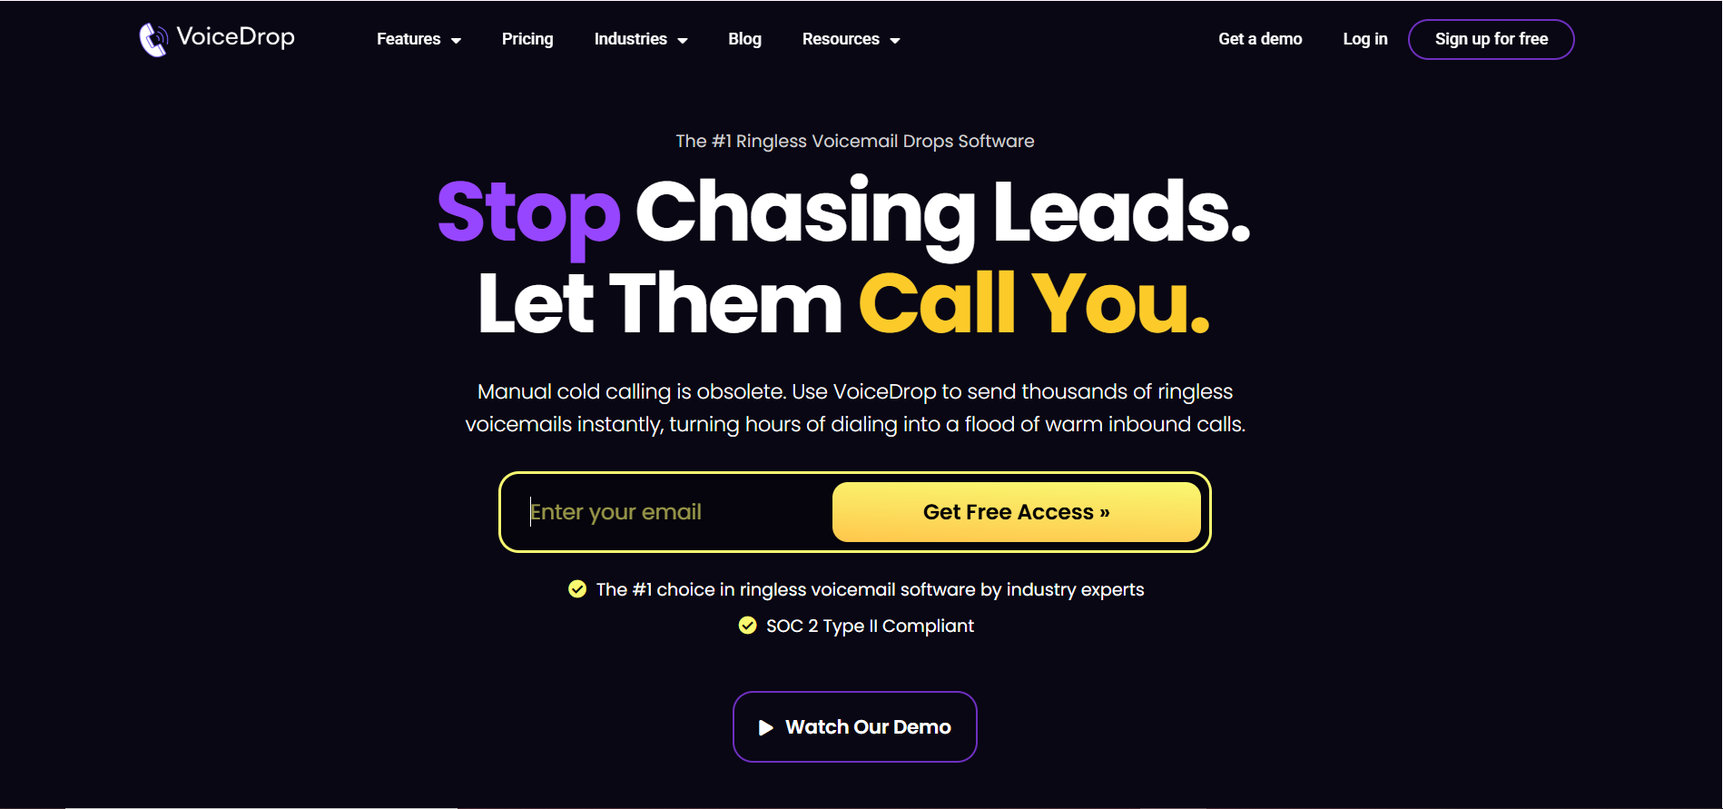
Step 2: Click on the pricing tab from the top bar, and select a plan that suits your outreach needs.
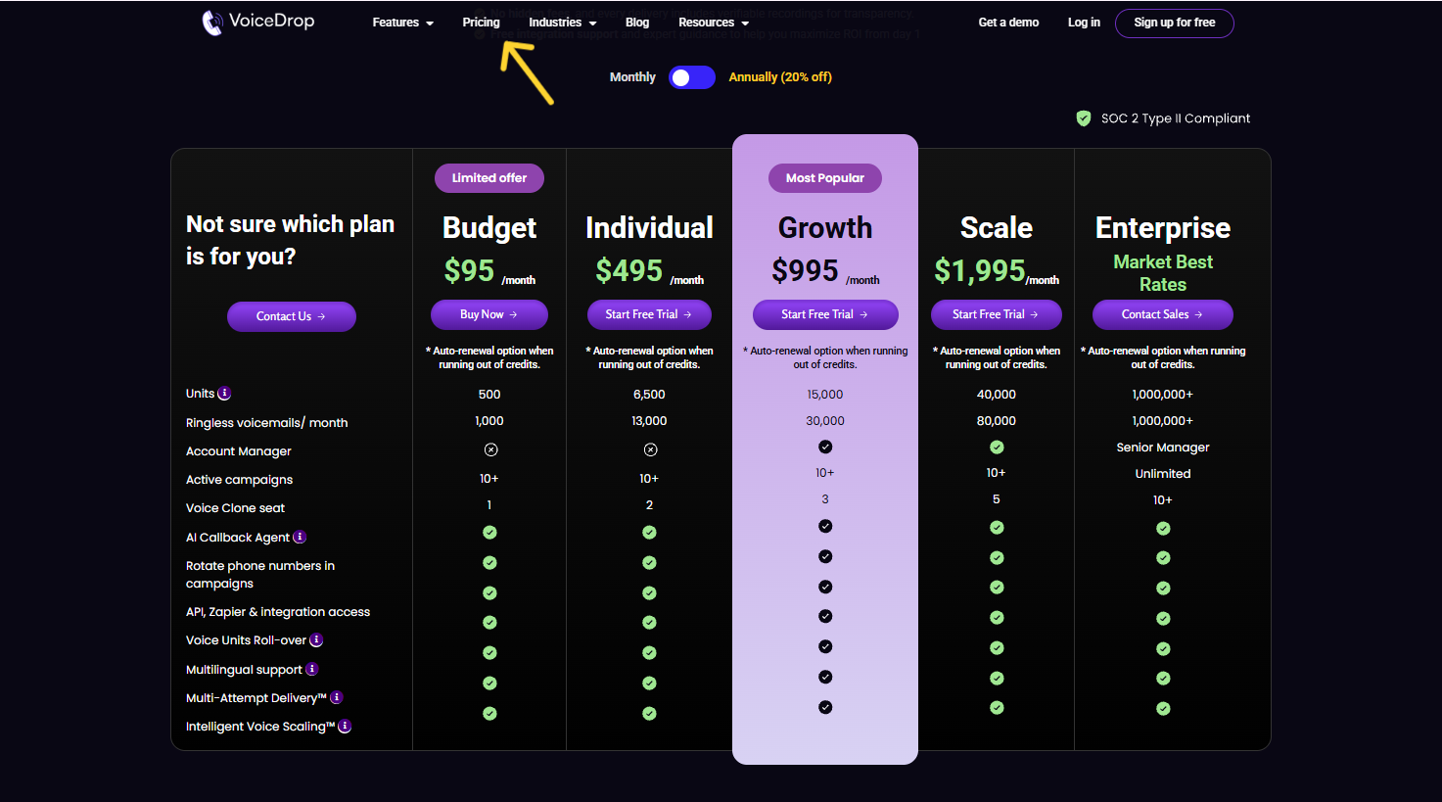
Step 3: Now, sign up on VoiceDrop by entering your email ID.
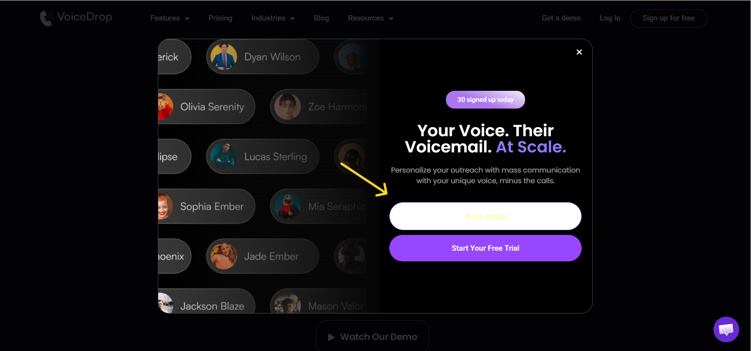
Tip: You are free to use the platform's trial to get $20 in free credits.
Step 4: At last, enter your payment details and apply the code VDRVMAI15 at checkout. You can pay using a credit or debit card.
Hurray! You have successfully claimed a VoiceDrop coupon code.

What if the VoiceDrop Coupon Does Not Work?
If you are facing any trouble while applying the VoiceDrop coupon, follow these steps to troubleshoot the problem.
- Double-check the code for typos, extra spaces, or incorrect characters. Ensure you are using verified codes like VDRVMAI15.
- Make sure the coupon is still valid and meets all the terms, like being for new users or annual plans.
- Clear your browser cache or try applying the code using a different browser or device.
- Contact VoiceDrop support for help, they offer live support, tickets, and phone assistance.

What are VoiceDrop Pricing Plans?
VoiceDrop offers flexible pricing to cater to different outreach volumes. Let’s break it down to find the perfect plan for your ringless voicemail campaigns.
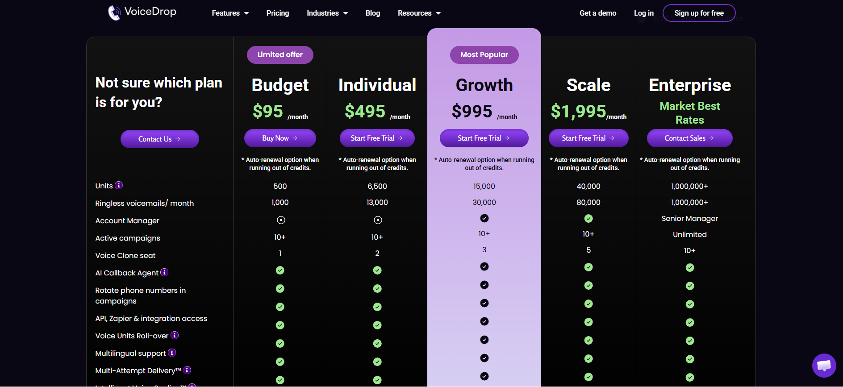
Plan | Pricing Details
Starter Tier | Starts from $95.00/month
Professional Tier | $495.00/month (Includes 6,500 units)
Static Voicemails | 0.5 voice units per successful RVM

Which Plan Should You Choose?
Now, comes the question: which setup should you choose? I have created a comprehensive table outlining VoiceDrop's core capabilities so you can make the right decision.
Feature | VoiceDrop Capabilities
Best For | B2B sales teams, telemarketers, and marketing agencies
Voice Units | Up to 6,500 units on the $495 plan (1 unit = 150 characters)
AI Voice Cloning | Included – clone your voice from a 60-second recording
Integrations | Zapier, HubSpot, Make, and full API access
Security & Compliance | SOC 2 Type II Compliant, strict DNC list management
Analytics | Campaign performance tracking and spam report checks
Delivery Tech | Multi-Attempt Delivery™ & Intelligent Voice Scaling™
Support | Phone, Email, Live support, Tickets, and hands-on Training

More Ways to Save on VoiceDrop
Besides using the main VoiceDrop coupon, here are a few smart ways to save more:

1. Test with Free Credits
Take advantage of the $20 in free credits to test up to 200 messages over a 5-day trial period. It’s a risk-free way to measure the response rate before subscribing.

2. Switch to Annual Billing
Opt for annual billing to save up to 35% off your VoiceDrop subscription, drastically reducing your monthly overhead.

3. Utilize Static Voicemails
If you don't require AI personalization for a specific campaign, you can send static ringless voicemails, which cost only 0.5 voice units per successful drop.

4. Look Out for Holiday Discounts
Big sales happen around holidays like Black Friday and Cyber Monday. VoiceDrop occasionally runs deep discounts, so keep an eye out for these deals.

Is VoiceDrop Worth the Price? (Quick Review)
I would say, yes, VoiceDrop is worth the price for teams looking to generate warm inbound calls. Here are a few pros and cons to help you understand whether VoiceDrop's ringless voicemail technology is right for you.
✅ Pros | ❌ Cons
Proven to drive a 478% increase in booked meetings and 276% increase in callbacks. | Limited to voicemail communication only.
Non-intrusive message delivery straight to the recipient's voicemail box. | Potential imperfections in AI voice cloning.
Seamless API and CRM integrations (Zapier, HubSpot). | Requires extensive contact lists to be highly effective.
Strict TCPA-compliant campaigns with automated DNC management.

What is VoiceDrop?
VoiceDrop is an AI-powered B2B SaaS platform that specializes in ringless voicemail delivery. It enables businesses to send personalized voice messages directly into a recipient's voicemail inbox without actually ringing their phone.
Leveraging cutting-edge machine learning, the software clones a user's voice to create highly customized drops at scale. This method breaks through digital noise, acting as a non-intrusive, TCPA-compliant alternative to manual cold calling. If you're tired of dialing for hours, VoiceDrop is worth every dollar, especially with the 35% discount on annual plans.
👉 Still unsure? Grab the $20 free trial credits and see the results for yourself!

Conclusion – VoiceDrop Coupon Codes (2026) To Save Up to 40%
If you want a scalable, sales-focused tool that helps you generate warm leads faster, VoiceDrop's ringless voicemail technology is a top-tier choice. And with these verified VoiceDrop coupons, you can easily save 35% annually, grab 15% off your first month with code VDRVMAI15, or start with a 5-day free trial before paying anything.

Choose the plan that matches your campaign size, apply the best VoiceDrop promo code at checkout, and start launching ringless voicemail drops at a much lower cost.

Frequently Asked Questions

What is VoiceDrop?
VoiceDrop is a cutting-edge service that clones your voice and uses AI to send personalized, ringless voicemails at scale. It tailors messages based on recipient information to ensure a personal touch.

Does VoiceDrop offer a free trial?
Yes, VoiceDrop offers a free trial with $20 in credits. This equates to approximately 200 messages over a 5-day testing period.

Are ringless voicemails legal and compliant?
Yes, VoiceDrop is designed to help you build TCPA-compliant campaigns. It features strict DNC (Do Not Call) list management, spam report checks, and is SOC 2 Type II Compliant to ensure data security.

How many voicemails can I send per day?
You can easily send over 100 voicemails per day. The platform is built for unlimited scale, allowing you to send hundreds or even millions of voicemails depending on your needs.

Can I use my own phone numbers?
Yes, you can use a phone number you already own and rotate multiple numbers within your campaigns. Alternatively, you can buy verified numbers directly through the platform.

Can I integrate VoiceDrop with my CRM?
Absolutely. VoiceDrop offers seamless workflow integration with tools like Zapier, Make, and HubSpot, and provides full API access to connect with any app at no extra cost.

